- Segmentation
Lab2 Tasks

1. Generate kernels for 1st order derivatives (x and y) for Gaussian filter, the kernel generation function takes sigma as parameter and generates kernels of size 7xsigma.
2. Apply convolution on the image using the x and y derivative kernels.
3. Calculate the gradient magnitude from gradient images gx and gy
4. Apply double thresholding on the gradient magnitude.
5. The resultant image shows the edges of the input image.

1. . Generate kernels for 1st order derivatives (x and y) for Gaussian filter, the kernel generation function takes sigma as parameter and generates kernels of size 7xsigma.

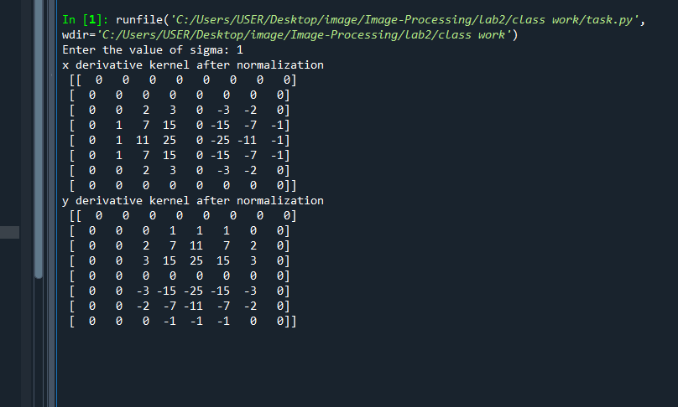
Figure 1.1: kernels for 1st order derivatives (x and y) for Gaussian filter with normalization within(-25,25)

2. Apply convolution on the image using the x and y derivative kernels.

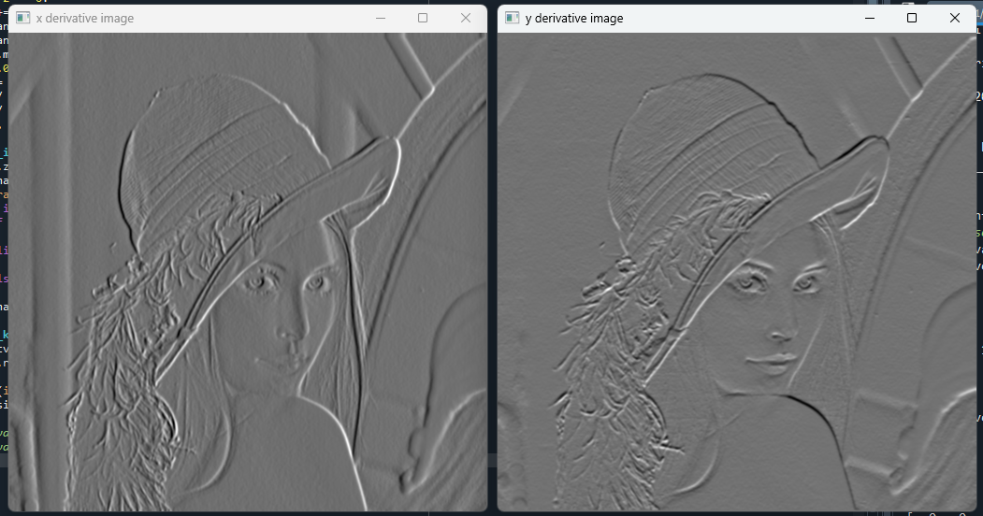
Figure 2.1: Convolution by x and y derivative kernel
3. Calculate the gradient magnitude from gradient images gx and gy
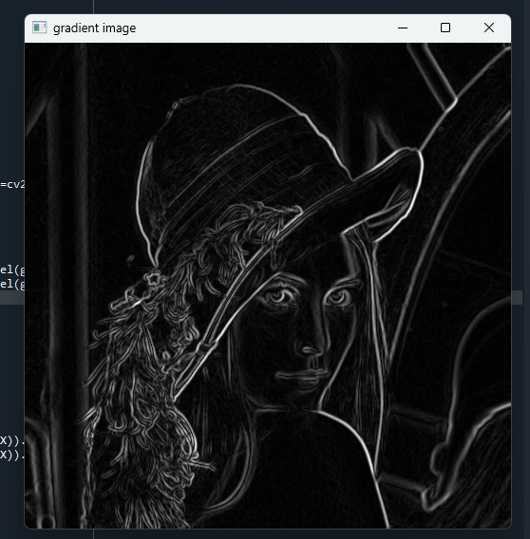
Figure 3.1: Gradient magnitude Image
4. Apply double thresholding on the gradient magnitude.
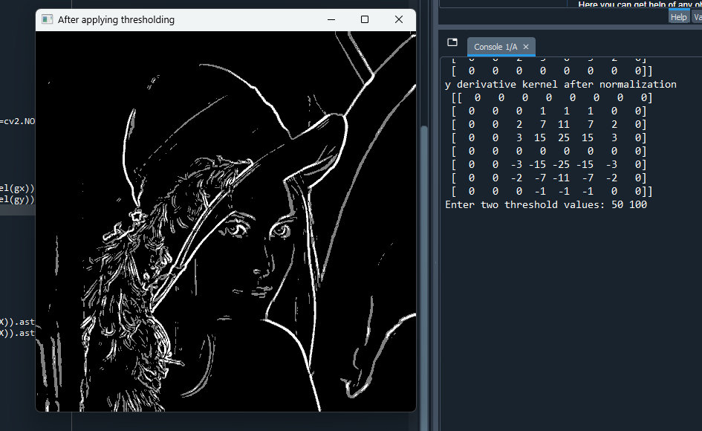

Figure 4.1: Threshold Image

- Assignment

- Apply Hysteresis Thresholding instead of double thresholding for detecting edges in gradient magnitude image. Observe the differences with your class work and discuss it in your report.


Figure 1.1: Double threshold Image

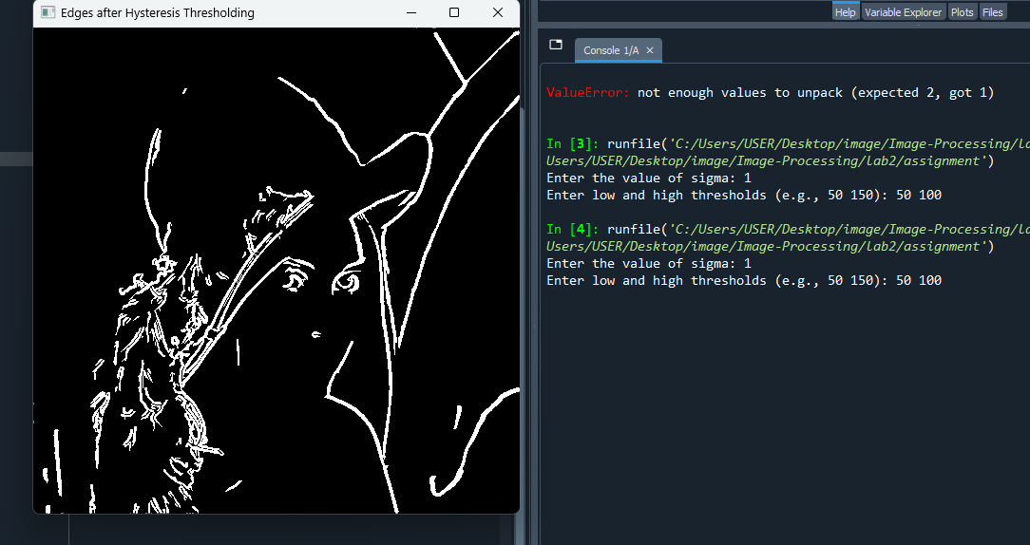
Figure 1.2: Hysteresis threshold Image
Difference between Double Thresholding and Hysteresis Thresholding:
- Double Thresholding: Classifies gradient pixels into strong, weak, and non-edge pixels based solely on intensity thresholds. Weak edges are not connected to strong edges are kept or removed arbitrarily, which can result in fragmented edges.

- Hysteresis Thresholding: Extends double thresholding by tracking weak edges connected to strong edges. Only weak edges connected to strong edges are preserved. This produces continuous, cleaner, and more accurate edges compared to simple double thresholding.

2.Apply Canny edge detection algorithm on the image using the opencv library function. Compare the output with the previous ones.


Figure 2.1: Hysteresis threshold Image

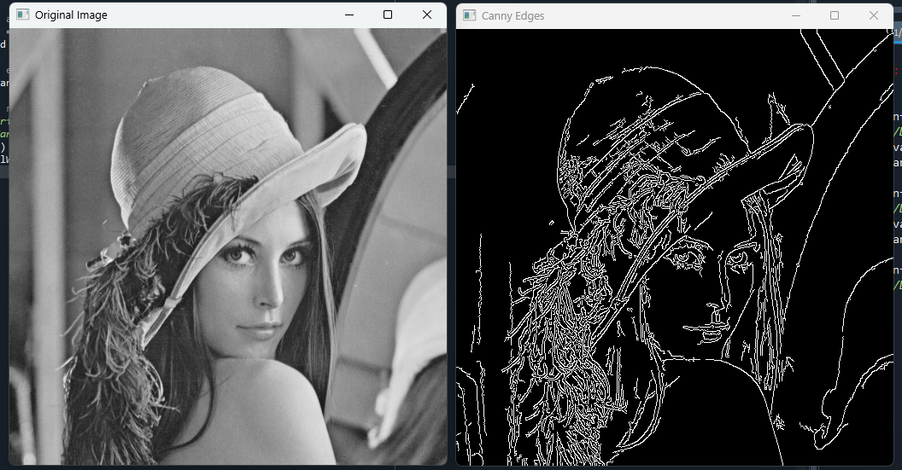
Figure 1.2: Canny Image

Canny Edge Detection vs. Custom Hysteresis Thresholding:
- Canny (OpenCV):
Performs Gaussian smoothing, gradient computation, non-maximum
Suppression, and hysteresis thresholding automatically.
Produces thin, clean, and well-connected edges with minimal noise.
- Custom Hysteresis Thresholding: Only applies hysteresis on the gradient magnitude without non-maximum suppression. Edges may be thicker and less precise, with more noise compared to Canny.
Observation: Canny gives more accurate and visually refined edges, while custom hysteresis is a simpler approximation.

CSE 4128: Image Processing and Computer Vision Laboratory
Assignment No:02
Assignment Name: Segmentation

By

Md Rauful Islam Tamim
Roll: 2007009



Department of Computer Science and Engineering
Khulna University of Engineering & Technology
Khulna 9203, Bangladesh
August, 2025

